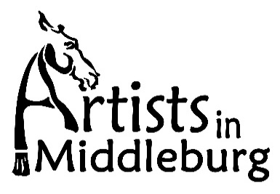

Application: General Information and Form

Please make checks out to Artists in Middleburg or AiM. MC, VISA and AE are also accepted.

Promotion: Promotion will include wide-spread marketing efforts, including sending announcements to: the Artists in Middleburg list, local and regional publications, businesses, local town/offices and more. Artists are also encouraged to promote the event through their networks. AiM reserves the right to use photos of accepted artwork in advertising and program promotion.

Insurance: All artists shall be solely and exclusively responsible to insure properly and adequately their work and property. By submitting this application, the artist agrees to fully and finally release the Artists in Middleburg and Dan Kaseman, its directors, officers, employees or any volunteers involved with the exhibit of any and all responsibility for any damage or loss to any artwork during the time of the exhibition, its set up and take down. Be aware that insurance policies in effect will not provide coverage for damage or loss due to fire, theft or burglary and vandalism. The artist agrees to assume all risk of damage to or loss of his/her own art from whatever cause. The transport, installation and removal of the artworks are not covered by insurance.

Application Form
Artists in Middleburg (AiM)
Exhibition Title________________________________

Name________________________________________________________________
Address, include town/city and zip code: ___________________________________________________
Signature_____________________________________________________________
By signing, you agree to all terms of this application.
Phone numbers:
Home __________________________ Cell__________________________________
Email address_________________________________________________________
Website_____________________________________________________________
Medium______________________________________________________________
Payment Method: Check_______
MC_______ VISA_______ AE_______
Credit card number_________________________________ Exp. Date_________
Security Code_______
*Please include: artist bio and statement, and Artist’s Perspective Statement (will be included on gallery label).

Application Form Date Received: ______________
Artists in Middleburg (AiM)
Date Notified: ______________

PART II

Artist Name: __________________________________________________

Address, include town/city and zip code: ___________________________________________________

Phone: ______________________________Email:_________________________________

...................................................................................................................................................

Submission #1 ACCEPTED YES_____ NO _____ SOLD: _____

Title: __________________________________________________________

Medium: _________________________ Price: _______________

Size (including frame):______________________

....................................................................................................................................................

Submission #2 ACCEPTED YES_____ NO _____ SOLD: _____

Title: __________________________________________________________

Medium: _________________________ Price: _______________

Size (including frame):______________________

....................................................................................................................................................

Submission #3 ACCEPTED YES_____ NO _____ SOLD: _____

Title: __________________________________________________________

Medium: _________________________ Price: _______________

Size (including frame):______________________

**** Sawtooth hangers are not accepted; Painting must be properly wired for hanging
**** Unframed paintings must be gallery wrapped with painted edges

